**Executive Summary**

In this project, our main objective was to make sense of the wealth of customer data at our disposal and translate it into actionable recommendations backed by solid data and insights. Right from the outset, our focus was on creating meaningful categories for our customers based on their unique behaviors.

We began by categorizing customers into segments to test whether Elena's hypothesis about specific customer preferences for perks held true. This involved a detailed analysis of customer behavior to understand their likes and dislikes better.

Here are the key insights we've uncovered:

1. **Customer Segments By Staying Night in Hotel:** 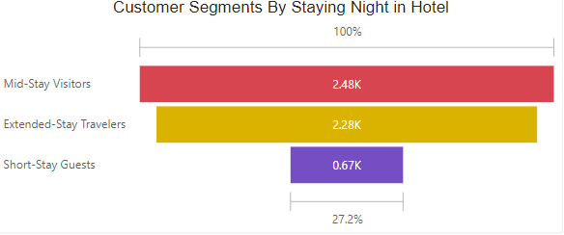

* We found three distinct customer groups based on the number of nights they stay in hotels: Mid-Stay Visitors, Extended-Stay Travelers, and Short-Stay Guests.
* Mid-Stay Visitors and Extended-Stay Travelers are the largest segments.
* Extended-stay customers often seek convenience, and offering free meals can make their stay more comfortable and cost-effective.
* Recommendations: Offering free hotel meals, particularly breakfast or meal vouchers, could entice Mid-Stay and Extended-Stay guests, enhancing their experience and promoting loyalty.

1. **Customer Segments By Checked Bags:**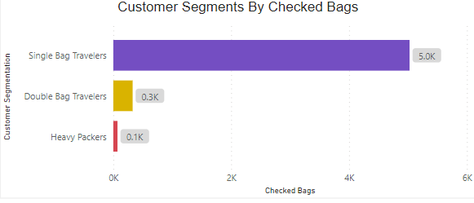

* We categorized customers into three segments based on the number of checked bags they typically use: Single Bag Travelers, Double Bag Travelers, and Heavy Packers.
* Single Bag Travelers make up the majority of travelers.
* By offering such services to specific customer groups, airlines and travel companies can attract and retain customers who value this convenience while tailoring their approach to different travel preferences
* Recommendations: Promoting free checked bag services as a loyalty perk for Single Bag Travelers can encourage more bookings.

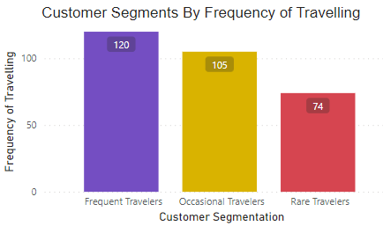

1. **Customer Segments By Frequency of Traveling:**

* Customers were segmented into three groups based on their frequency of travel: Frequent Travelers, Occasional Travelers, and Rare Travelers.
* Frequent Travelers dominate this segment.
* Occasional travelers may prioritize value and extra perks for their vacation experience.
* Recommendations: Offering a perk like "1 night free at a hotel with flight" as part of vacation packages can attract Occasional Travelers.

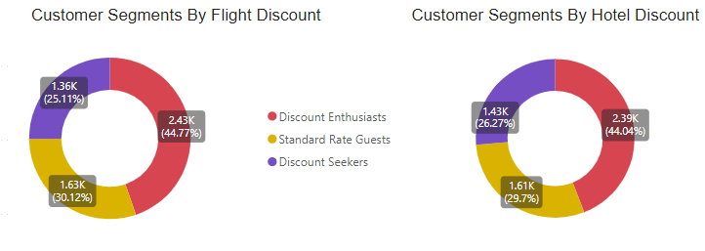

1. **Customer Segments by Hotel and Flight Discount:**

* We identified three customer segments: Discount Enthusiasts, Discount Seekers, and Standard Rate Guests.
* Discount Enthusiasts form the largest group.
* They are the customers who are passionate about discounts on hotel bookings
* Recommendations: Providing exclusive discounts and promotions to Discount Enthusiasts can enhance their loyalty.



1. **Customer Segments By Frequency of Traveling:**

* Customers were once again categorized by their frequency of travel: Frequent Travelers, Occasional Travelers, and Rare Travelers.
* Frequent Travelers hold the majority.
* By segmenting customers offering tailored perks like no cancellation fees, we can meet their specific needs and preferences.
* This approach can enhance customer satisfaction, attract bookings, and encourage loyalty within each customer segment.
* Recommendations: For Frequent Travelers, offering the perk of "no cancellation fees" can be a powerful incentive, given their dynamic travel schedules.

In conclusion, by tailoring our perks to specific customer segments, we can enhance customer satisfaction, attract more bookings, and foster loyalty. Understanding the unique preferences and behaviors of our customers allows us to provide them with relevant and appealing offers, ultimately benefiting our business.